Lab2 Assignment: Advance Algorithms

Name: Chea Ilong

ID: 100022

Group: 1

Gen: 10

Ex1: Person  
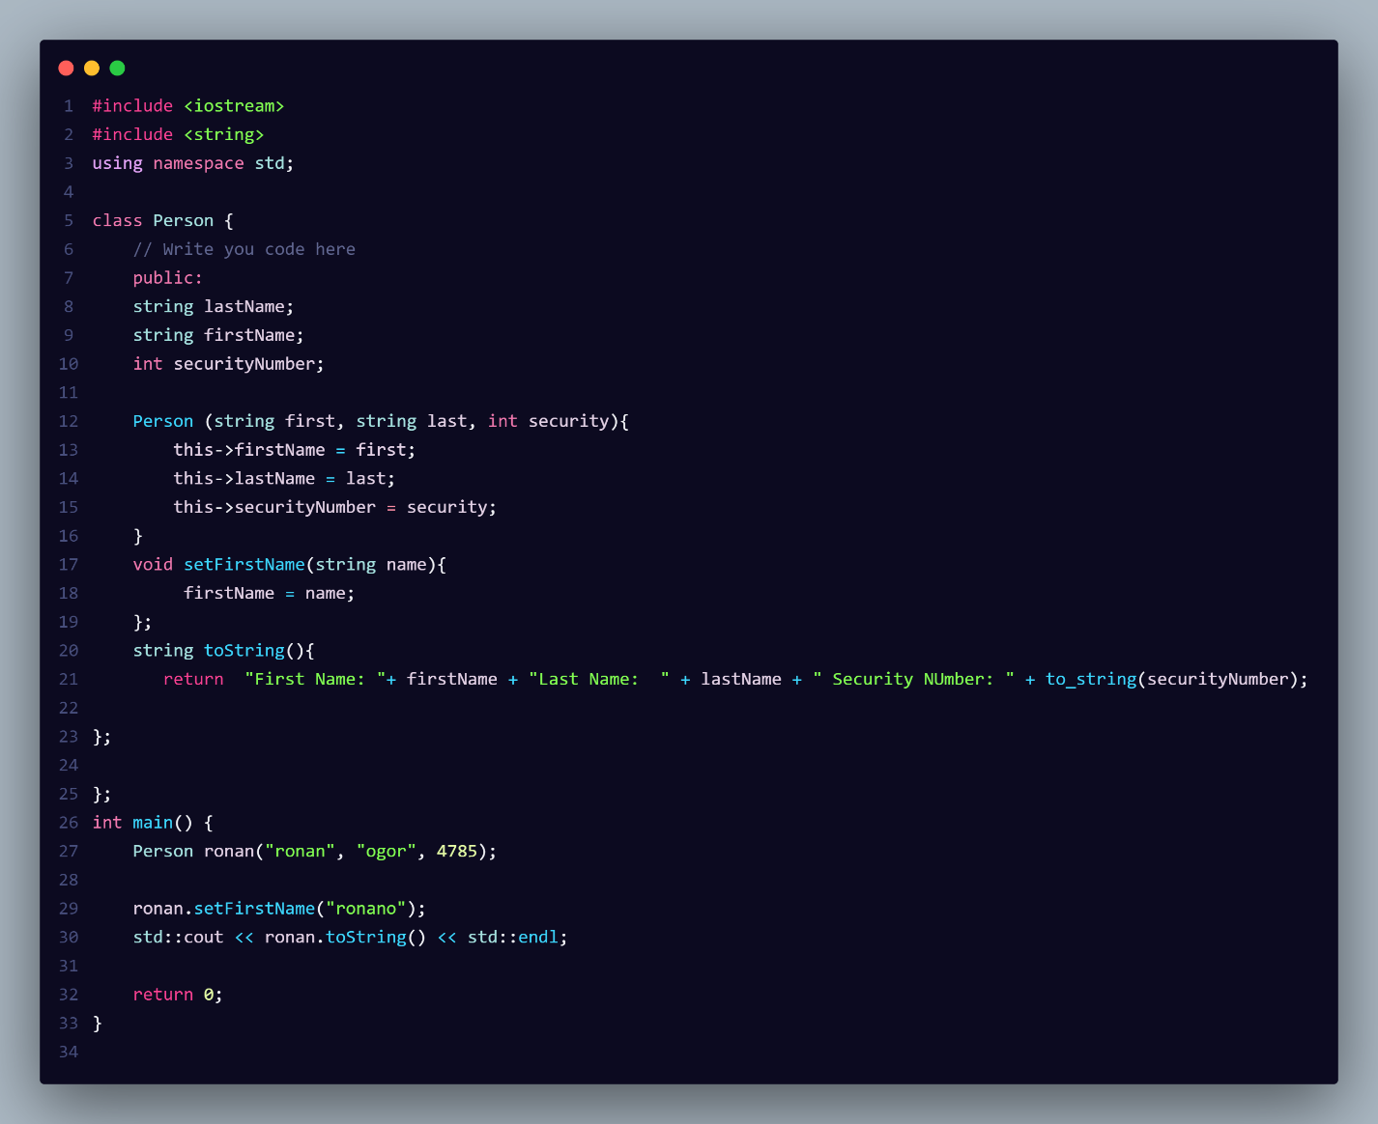

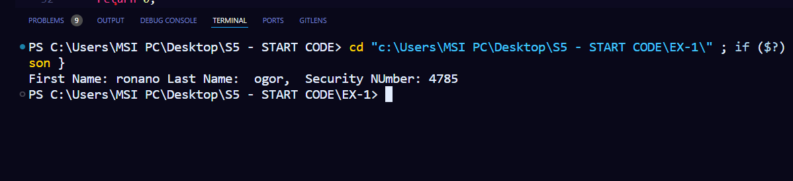

Ex2: Bank

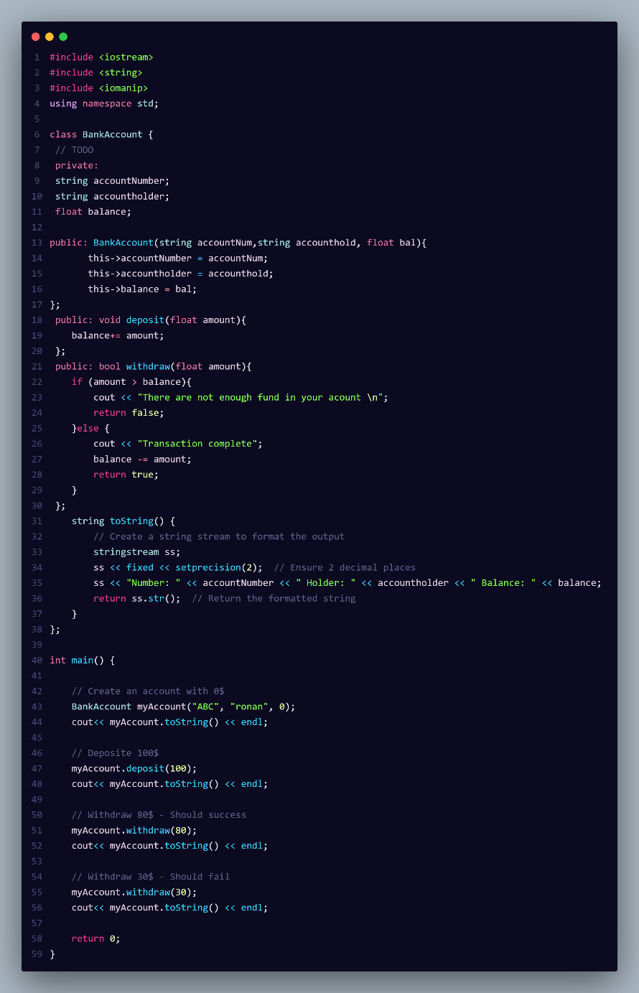

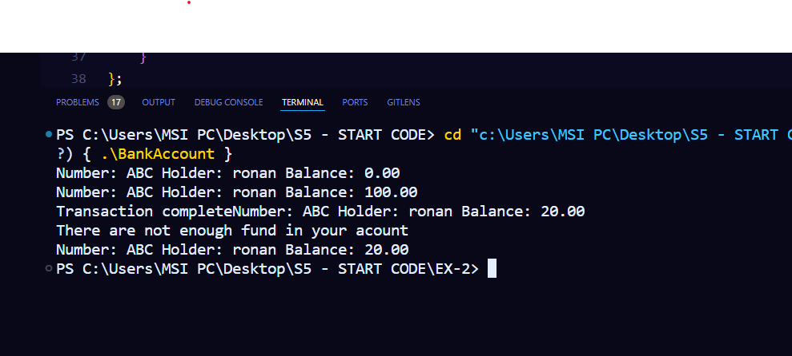

Ex3: Shape

